Prices & Services Winter 2020-2021

At Wholeycow, we care about your health and wellbeing.
We aim to enhance and uplift you to be the best you can be, offering strength and conditioning fitness classes to the mobilising or deeply relaxing yoga classes.
We have the most experienced massage therapists in town, offering a range of Sports, Relaxation and Rebalancing treatments as well as Beauty Therapies.

Our studio is centrally located with separate yoga and fitness rooms as well as a therapy room. We are also able to offer private yoga, personal training and massage at your own chalet, apartment or hotel.

You will find a list of our products and prices online, as well as profiles of our amazing team of therapists and teachers, visit our website: www.wholeycow.ch

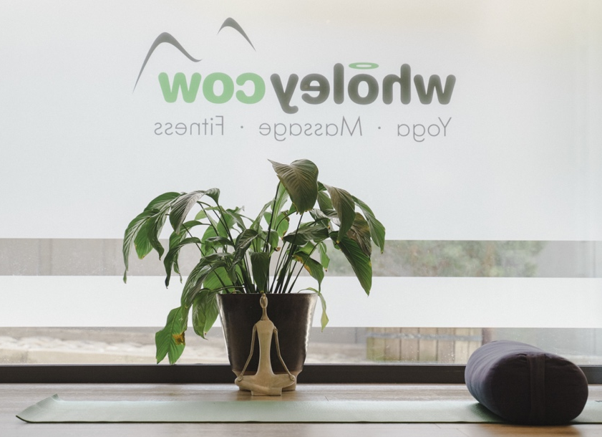

‘Feel better, be better’’

MASSAGE & THERAPIES
Our skilled team can use a number of these techniques to offer you the perfect massage for your needs.
Regular massages are 60 mins or 90 mins. Sports massage can be 45 mins in the studio only.

Deep tissue massage - A very popular strong massage which works deeply into the muscles, connective tissue and fascia. It is an effective way to release chronic tension with a holistic treatment which is perfect to ease tired or tight muscles after a day on the slopes.
Sports massage - Sports massage is done with the principal mandate of returning you to your desired sports activity with the same or an even better level of function. This massage will release muscle tension and restore balance to the musculoskeletal system. Sports massage can also help to prevent injuries, which might otherwise be caused by overuse.
Relaxation massage - A massage aimed at relaxing not just your body but your mind as well, this treatment will bring you back in balance. Relaxation massage is gentler than deep tissue massage and better suited for people who prefer a less intense treatment to reach deep relaxation.
Thai massage - Traditional Thai yoga techniques that have been used for over 2500 years. The massage is given on a soft mat on the floor, while you wear loose comfortable clothes, and no oil is used. It combines elements of yoga, shiatsu, reflexology and acupressure, with deep massage. It helps to stretch the muscles and mobilise the joints whilst deeply relaxing your mind & body.
Possibility to extend with a Thai foot massage. Deep and invigorating for the feet and lower legs. This is a wonderful treatment after skiing when the lower body is tired and by working along the meridians you will also invigorate the whole body and mind.
Hot Stone massage - A treatment that involves the use of smooth, basalt heated stones. Those will be placed on specific points on your body and may be used while giving the massage. The localized heat and weight of the stones warm and relax muscles, allowing the therapist to apply deeper pressure to those areas without causing discomfort.
Pregnancy massage - A massage for pregnant ladies to ease away the aches and pains during pregnancy, using only almond oil with no essential oils. You will be supported on the table with pillows and a heated blanket for comfort. Ladies should be past the first trimester of pregnancy and have no pregnancy related complications. The perfect way to relieve the body from tensions and relax the mind during this special time!
Energy Healing treatment - Our experienced and intuitive therapist will guide you through a transformative healing process. She will use a combination of techniques, including reiki, chakra balancing and Chi abdominal massage to rebalance the body’s energetic system. This powerful treatment is ideal for those whose healing may benefit from addressing emotional, mental or energetic blockages.
FARFALLA NOURISHING FACIAL
With Farfalla aromatherapy expertise, we have created the perfect Nourishing Facial for the mountains with grapefruit to cleanse and tone, aloe vera to repair and restore, bergamot and lavender to calm and rose with geranium to hydrate and regenerate
Please find our specific therapies and treatments on our website.

GROUP CLASSES
YOGA
We love to share our yoga passion. We have classes for beginners, the experienced,
the strong, for the stressed and tired and for those who are recovering from injury.

Hatha ∙ Vinyasa Flow ∙ Dynamic ∙ Yin ∙ Breathwork
Fit & Flow ∙ Restorative ∙ Aerial ∙ Après Ski Yoga
PILATES
Pilates mat classes are designed to build core abdominal strength & stability as well as give overall body tone with proper alignment. Our classes are super effective, low impact and support many other sports including skiing, golf and tennis.

PILATES REFORMER
The reformer machines allow you to use your body weight to move the machine against resistance from springs. This method is amazingly beneficial for rehabilitation and recovery from injury to develop core stability and target small muscle groups.
We have two machines at the studio so you can book individual or duet sessions with a friend.

FITNESS
Our fitness classes will put you at the top of your game, whether you are looking to tone up, get strong, lose weight, improve cardio performance or build muscle.
TRX ∙ Spinning ∙ Cardio Box ∙ Cross Training ∙
Ballet Barre ∙ Strength Circuits ∙ HIIT ∙ Tai Chi

PERSONAL TRAINING & PRIVATE CLASSES

Personal Training and Private Classes are a great way to stay motivated and achieve your goals, especially if you need flexibility with your schedule or you have specific injuries, conditions or fitness targets.
We offer individual sessions at the studio or outside for fitness training, or for small groups (maximum 5) at any time that works for you.

PRICES
MEMBERSHIPS
Annual membership (12 months) | 50 CHF
Seasonal membership (6 months) | 30 CHF
Membership benefits include:
* discount on every class price
* 10% off massage and therapies
* discounts on special events & workshops

CLASSES | Member (CHF) | Non-member (CHF)
Drop In | 25 | 30
5 class pass (valid for 3 months) | 115 | 135
10 class pass (valid for 5 months) | 200 | 250
20 class pass (valid for 6 months) | 380 | ─
50 class pass (valid for 12 months) | 900 | ─

PRIVATE TRAINING | Member (CHF) | Non-member (CHF)
Private Yoga or Pilates | 110 | 120
10 sessions | 990 | 1080
Personal training | 110 | 120
10 sessions | 990 | 1080
Pilates reformer or Tower private | 110 | 120
10 sessions | 990 | 1080
Duet Pilates Reformers or Towers private  (2 people) | 130 | 140
10 sessions | 1080 | 1170
Private Group Class (2 - 5 people) | 120 | 120
Private Group Class (more than 5 people) | add an extra 20 CHF per person

TREATMENTS
MASSAGE |  | Members -10%  Studio Only
45 mins massage | 95 CHF
60 mins massage | 125 CHF
90 mins massage | 180 CHF
FACIALS with Farfalla products |  | Members -10%  Studio Only
Nourishing Facial (60 mins) | 140 CHF
Facial (60 mins) & Massage (30 mins) | 195 CHF
Facial (60 mins) & Massage (60 mins) | 240 CHF
Please Note: We can come to your accommodation for an additional 25 CHF call-out fee

